Electric Circuits & Electronics Design Lab

EE 316-01

# Lab 1: Circuits Review

By: Jaiden Gann

Lab Section 316-01

Lab Date: 6/1/22

Lab Due: 6/8/22

## Introduction:

The purpose of this lab is to review key concepts of circuit theory which will be used throughout the lab and probably the semester. We will be looking at Ohm’s law, Kirchhoff’s voltage and current laws, and Norton and Thevenin equivalents using theoretical analysis, simulations, and experiments. This report will have 5 main sections. First is the theoretical analysis which would normally be done as the pre-lab along with the Multisim simulations. Then we have the physical circuits which are constructed on breadboards in lab. Afterwards, we compare the results from those 3 sections and conclude with an analysis of the results.

## Theoretical Analysis:

To begin, we considered the circuit given in Figure 1 using theoretical circuit analysis techniques, specifically mesh current analysis to find branch currents, node voltages, loop currents, and branch voltages.

The analysis was performed three times. The first time we assumed the resistors were the listed values. The second and third time, we assumed the resistors were ten percent above and below the nominal value respectively. The work for this analysis is attached in Appendix 1. The results of the analysis can be seen in Tables 1 through 3.

The following assumptions were made for component values below:

**Vs = 5.0 V**

**R1 = R2 = R3 = 100 Ohms**

**R4 = R5 = 1000 Ohms**

**R6 = R7 = 2200 Ohms**

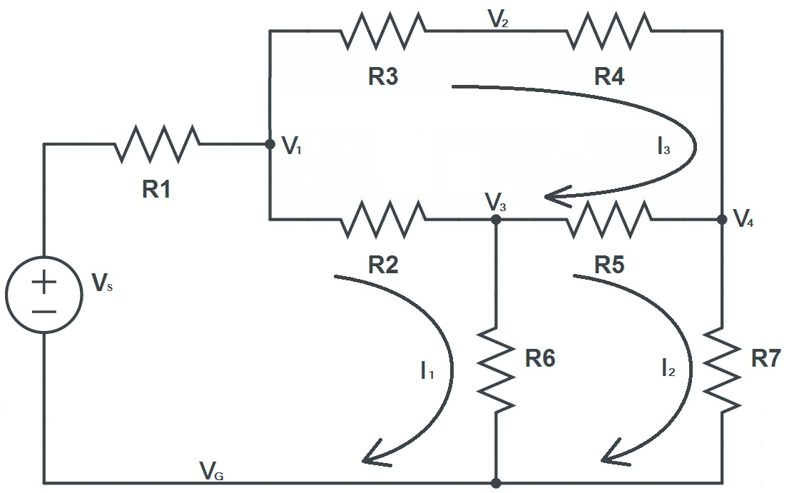

Figure 1: The Circuit Under Analysis

Table 1: Voltages and Currents with Resistors at Nominal

|  |  |  |  |  |
| --- | --- | --- | --- | --- |
| Branch Node or Loop # | Branch Voltages (V) | Branch Currents (mA) | Node Voltages (V) | Loop Currents (mA) |
| 1 | 0.363 | 3.630 | 4.637 | 3.630 |
| 2 | 0.271 | 2.710 | 4.545 | 1.650 |
| 3 | 0.092 | 0.920 | 4.366 | 0.920 |
| 4 | 0.920 | 0.920 | 3.625 |  |
| 5 | 0.750 | 0.750 |  |  |
| 6 | 4.365 | 1.980 |  |  |
| 7 | 3.630 | 1.650 |  |  |

Table 2: Voltages and Currents with Resistors at -10%

|  |  |  |  |  |
| --- | --- | --- | --- | --- |
| Branch Node or Loop # | Branch Voltages (V) | Branch Currents (mA) | Node Voltages (V) | Loop Currents (mA) |
| 1 | 0.363 | 4.030 | 4.637 | 4.030 |
| 2 | 0.271 | 3.010 | 4.545 | 1.830 |
| 3 | 0.092 | 1.020 | 4.366 | 1.020 |
| 4 | 0.920 | 1.020 | 3.625 |  |
| 5 | 0.750 | 0.810 |  |  |
| 6 | 4.365 | 2.200 |  |  |
| 7 | 3.630 | 1.830 |  |  |

Table 3: Voltages and Currents with Resistors at +10%

|  |  |  |  |  |
| --- | --- | --- | --- | --- |
| Branch Node or Loop # | Branch Voltages (V) | Branch Currents (mA) | Node Voltages (V) | Loop Currents (mA) |
| 1 | 0.363 | 3.300 | 4.637 | 3.300 |
| 2 | 0.271 | 2.470 | 4.545 | 1.500 |
| 3 | 0.092 | 0.830 | 4.366 | 0.830 |
| 4 | 0.920 | 0.830 | 3.625 |  |
| 5 | 0.750 | 0.670 |  |  |
| 6 | 4.365 | 1.800 |  |  |
| 7 | 3.630 | 1.500 |  |  |

We next performed theoretical analysis on the circuit seen in Figure 2 to determine both its Norton and Thevenin equivalent circuits using the six steps outlined in the lab manual.

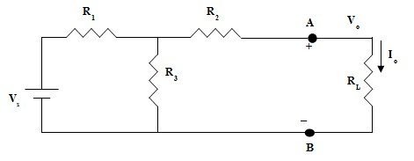

Figure 2: The Circuit to be Replaced with an Equivalent

We assumed the following about the values in the circuit:

**Vs = 5.0 V**

**R1 = R2 = R3 = 1000 Ohms**

The work for finding both Voc and Isc and the sketches of the Thevenin and Norton circuits can be seen in Appendix 1. The calculated values are as follows:

**Voc = 2.5V**

**Isc = 1.667mA**

**Rth = 1.5K Ω**

## Simulations:

For the next phase of the lab, we built and analyzed circuits in Multisim. We began in the same place as we did for the theoretical analysis, with the circuit in Figure 1. We used the same component values as before, again repeating the analysis at nominal and at plus and minus ten percent. The circuit created in Multisim can be seen in Figure 3, with Figure 3 showing voltage measurements and showing current readings. The values measured here differ only in rounding in some cases from the theoretical analysis. They are given for all three cases in Tables 4-6.

Figure 3: Voltage & Current Readings at Nominal

Table 4: Simulated Values at Nominal

|  |  |  |  |  |
| --- | --- | --- | --- | --- |
| Branch Node or Loop # | Branch Voltages (V) | Branch Currents (mA) | Node Voltages (V) | Loop Currents (mA) |
| 1 | 0.364 | 3.635 | 4.637 | 3.635 |
| 2 | 0.272 | 2.72 | 4.545 | 1.65 |
| 3 | 0.092 | 0.916 | 4.365 | 0.916 |
| 4 | 0.915 | 0.915 | 3.63 |  |
| 5 | 0.735 | 0.735 |  |  |
| 6 | 4.364 | 1.984 |  |  |
| 7 | 3.63 | 1.65 |  |  |

Table 5: Simulated Values with Resistors at -10%

|  |  |  |  |  |
| --- | --- | --- | --- | --- |
| Branch Node or Loop # | Branch Voltages (V) | Branch Currents (mA) | Node Voltages (V) | Loop Currents (mA) |
| 1 | 0.363 | 4.040 | 4.637 | 4.040 |
| 2 | 0.272 | 3.022 | 4.547 | 1.833 |
| 3 | 0.090 | 1.016 | 4.365 | 1.016 |
| 4 | 0.915 | 1.017 | 3.630 |  |
| 5 | 0.735 | 0.817 |  |  |
| 6 | 4.365 | 2.205 |  |  |
| 7 | 3.630 | 1.834 |  |  |

Table 6: Simulated Values with Resistors at +10%

|  |  |  |  |  |
| --- | --- | --- | --- | --- |
| Branch Node or Loop # | Branch Voltages (V) | Branch Currents (mA) | Node Voltages (V) | Loop Currents (mA) |
| 1 | 0.364 | 3.304 | 4.636 | 3.303 |
| 2 | 0.272 | 2.472 | 4.544 | 1.500 |
| 3 | 0.092 | 0.832 | 4.365 | 0.832 |
| 4 | 0.915 | 0.832 | 3.630 |  |
| 5 | 0.735 | 0.668 |  |  |
| 6 | 4.365 | 1.804 |  |  |
| 7 | 3.630 | 1.500 |  |  |

Next we considered the circuit in Figure 4, which we built in Multisim. Setting Rs at 100Ω and Vs at 5.0V we varied the value of the load resistor and recorded the value of the voltage across and current through the resistor. The circuit in Multisim can be seen in Figure 5 and the data collected can be seen in Table 7.

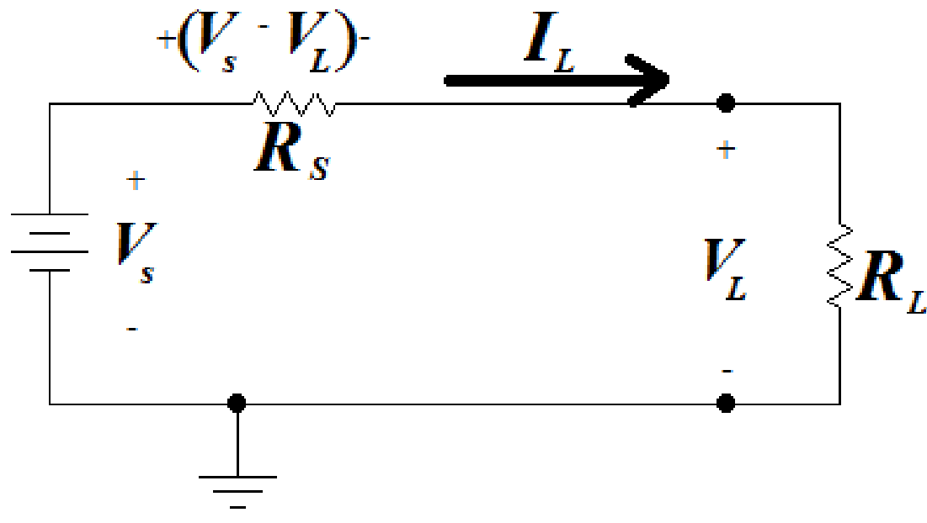

Figure 4: The Test Circuit

Figure 5: The Test Circuit in Multisim

Table 7: Multisim Data

|  |  |  |
| --- | --- | --- |
| RL | VL | IL A |
| 10 | 0.455 | 0.045 |
| 20 | 0.833 | 0.042 |
| 40 | 1.429 | 0.036 |
| 70 | 2.059 | 0.029 |
| 100 | 2.500 | 0.025 |
| 150 | 3.000 | 0.020 |
| 200 | 3.333 | 0.017 |
| 300 | 3.750 | 0.013 |
| 500 | 4.167 | 0.008 |
| 1000 | 4.545 | 0.005 |

Finally, we repeated the analysis from the theoretical portion of the lab for Norton and Thevenin equivalent circuits, again using the circuit in Figure 2. Figures 6 and 7 show the measurements of open circuit voltage and short circuit current respectively.

Figure 6: Open Circuit Voltage

Figure 7: Short Circuit Current

## Experimental:

For the last portion of the lab, we did the same things as prior but on a physical board to validate the conceptual results we obtained. We started with the same circuit from Figure 1, however, we only performed the analysis once, using only nominal values for components. The results can be seen in Table 8 of the results portion of this lab. Voltages were measured with a multi-meter placed on both ends of a resistor and currents were measured by removing one end of a resistor and attaching it to one multi-meter and placing the other multi-meter lead at the point where the resistor was previously attached.

Next we built the circuit from Figure 4 on the breadboard and repeated the measurements from Multisim. The results can be seen in Table 9 of the results portion of this lab.

The final experimental step in this lab was creating a Thevenin equivalent for the circuit given in Figure 2. We first built the circuit on the breadboard and used the multi-meter to measure the open circuit voltage and short circuit current. Those values are given below.

**Voc = 2.5**

**Isc = 1.65mA**

**Rth = 1.512K Ω**

Using these values, we were able to construct a Thevenin equivalent circuit using a 2.5-volt source and a 1.512K Ohm resistor in series with it. This circuit gave us the same open circuit voltage and short circuit current as the original circuit, but with only two components needed instead of four. We did not attempt to construct a Norton equivalent on the physical boards.

## Results and Discussion:

The first two tables have the data previously discussed in the last portion of this lab.

The values found here match closely with both the theoretical values and the simulated values in some cases and in others differ greatly. The smaller discrepancies can be explained by tolerances in the parts used experimentally and on the multi-meter. The huge discrepancies are probably from not obtaining the reading in the correct way.

Table 8: Simulated Values at Nominal

|  |  |  |  |  |
| --- | --- | --- | --- | --- |
| Branch Node or Loop # | Branch Voltages (V) | Branch Currents (mA) | Node Voltages (V) | Loop Currents (mA) |
| 1 | 0.36 | 3.627 | 4.7 | 3.627 |
| 2 | 0.273 | 25.51 | 4.6 | 1.69 |
| 3 | 88.42 mv | 0.93 | 4.4 | 0.93 |
| 4 | 92.8 mv | 0.93 | 3.6 |  |
| 5 | 0.740 | 0.002 |  |  |
| 6 | 4.4 | 2.12 |  |  |
| 7 | 3.6 | 1.69 |  |  |

Table 9: Breadboard Data

|  |  |  |
| --- | --- | --- |
| RL | VL | IL A |
| 10 | 0.48 | 0.044 |
| 20 | 0.87 | 0.040 |
| 40 | 1.47 | 0.035 |
| 70 | 2.1 | 0.029 |
| 100 | 2.56 | 0.024 |
| 150 | 3.06 | 0.019 |
| 200 | 3.40 | 0.016 |
| 300 | 3.81 | 0.011 |
| 500 | 4.23 | 0.008 |
| 1000 | 4.61 | 0.005 |

The results of this lab confirm several key circuits concepts those being: Ohm’s Law, Kirchhoff’s Voltage and Current Laws, and Thevenin and Norton equivalent circuits.

Ohm’s Law which is V=I*R can be seen in the analysis on the circuit given in Figure 5. Ohms law simply says the relationship between voltage and current is linear. When we plot the results from the simulation (as we have done in Figure 9), we see that the slope of this line is -103.77, meaning that as current increases voltage decreases. The y-intercept is 5.056 and the x-intercept is 0.005.

Figure 9: Voltage v. Current

Kirchhoff’s Voltage Law states that the sum of the voltages around any closed loop in a circuit must be zero. Our analysis of the circuit in Figure 1 confirms this. If we look at any closed loop in that circuit, we can sum the voltages and they come out to be zero plus or minus a small margin of error.

Kirchhoff’s Current Law states that the sum of currents entering and exiting any given node in a circuit must equal zero. Again, looking at Figure 1, we can sum the currents entering any given node and see that they all come out to be zero.

When looking at the Thevenin and Norton equivalent circuits we found that the circuits shared open circuit voltage and short circuit current as their more complex counterparts that they were emulating. Thus, using an equivalent circuit allows for easier analysis while still having the same functionality.

## Conclusion:

Overall, the results of the lab were closely in line with our expectations. There were only small discrepancies between the theoretical, simulation, and experimental results besides those due to human error. The circuit concepts we were trying to prove were verified by the results of the lab. This lab also provides a useful introduction to the software, lab tools, and how to properly measure what you’re looking for using said lab tools which will be used throughout the semester.

## Appendix 1:

Handwritten work for Figure 1

Handwritten work for Thevenin and Norton section

## Appendix 2:

Signed lab results

Figure 1’s Physical Board readings

Figure 4’s Physical board results

Thevenin and Norton Physical Board results

Pictures of Circuits

Figure 1 physical circuit

Figure 4 physical circuit

Thevenin and Norton Physical circuit used to get values